RESOLUTION NO.__________

RE: CERTIFICATE OF APPROPRIATENESS UNDER THE

PROVISIONS OF THE ACT OF THE PENNSYLVANIA

LEGISLATURE 1961, JUNE 13, P.L. 282 (53

SECTION 8004) AND BETHLEHEM ORDINANCE NO.

3952 AS AMENDED.

WHEREAS, it is proposed discuss changes to the proposal and review materials at 324 S New Street.

NOW, THEREFORE, BE IT RESOLVED by the Council of the City of Bethlehem that a Certificate of Appropriateness is hereby granted for the work.

Sponsored by: (s)

(s)

ADOPTED BY COUNCIL THIS DAY OF

(s)

President of Council

ATTEST:

(s)

City Clerk

HISTORIC CONSERVATION COMMISSION

CASE # 590– It is proposed to discuss changes to the proposal and review materials at 324 S New Street

OWNER/APPLICANT: Bethlehem Parking Authority / Kevin Livingston

The Commission upon motion by Mr. Hudak seconded by Mr. Lousch adopted the proposal that City Council issue a Certificate of Appropriateness for the proposed work described herein:

1. The proposal to discuss changes to the proposal and review materials at 324 S New Third Street was represented by the architect and construction manager.
2. The changes to the design of the building will include the following requested by the Commission:
   1. The canopies on the east and west will be flat roofs with suspension rods or cables
   2. The top cornices of the main parts of the building were reduced to a simple cap
   3. The other cornices vary in size and the tower top cornice was raised to be located just below the screening material
   4. The lintels that spanned 4 windows now span only 2
   5. The wide openings at the rear of the garage were modified to be multiple rectangular openings with no arches
   6. Screening on the north façade is denser, as requested, and camouflages the angled concrete spandrels of the sloped parking
   7. The door requested for the west façade has will be located around the corner on the south façade, close to the Vine St. sidewalk.
3. Other changes will include:
   1. Concrete panels on the north façade at the connection of the elevated bridge will be brick instead of concrete.
   2. The Bethlehem Star will be eliminated from the top of the tower.
4. Materials presented to the Commission and approved are:
   1. The brick will be Summitville 01012 Dungannon with texture
   2. Glass will be clear with no visible tint
   3. The precast concrete will be as shown in the sample submitted
   4. The metal canopies and storefront framing will be bronze aluminum
   5. The mesh will have two densities as submitted to the Commission.
   6. Caulk joints between brick panels will match the color of the brick
   7. Caulk joints in the concrete cornices and other concrete elements will match the concrete color
5. No signage or exterior lighting has been approved at this time.
6. The proposed motion was unanimously approved.

CU: cu

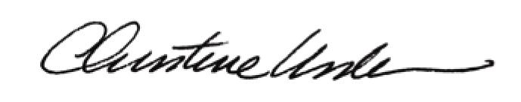

By:

Date of Meeting: May 16, 2016 Title: Historic Officer